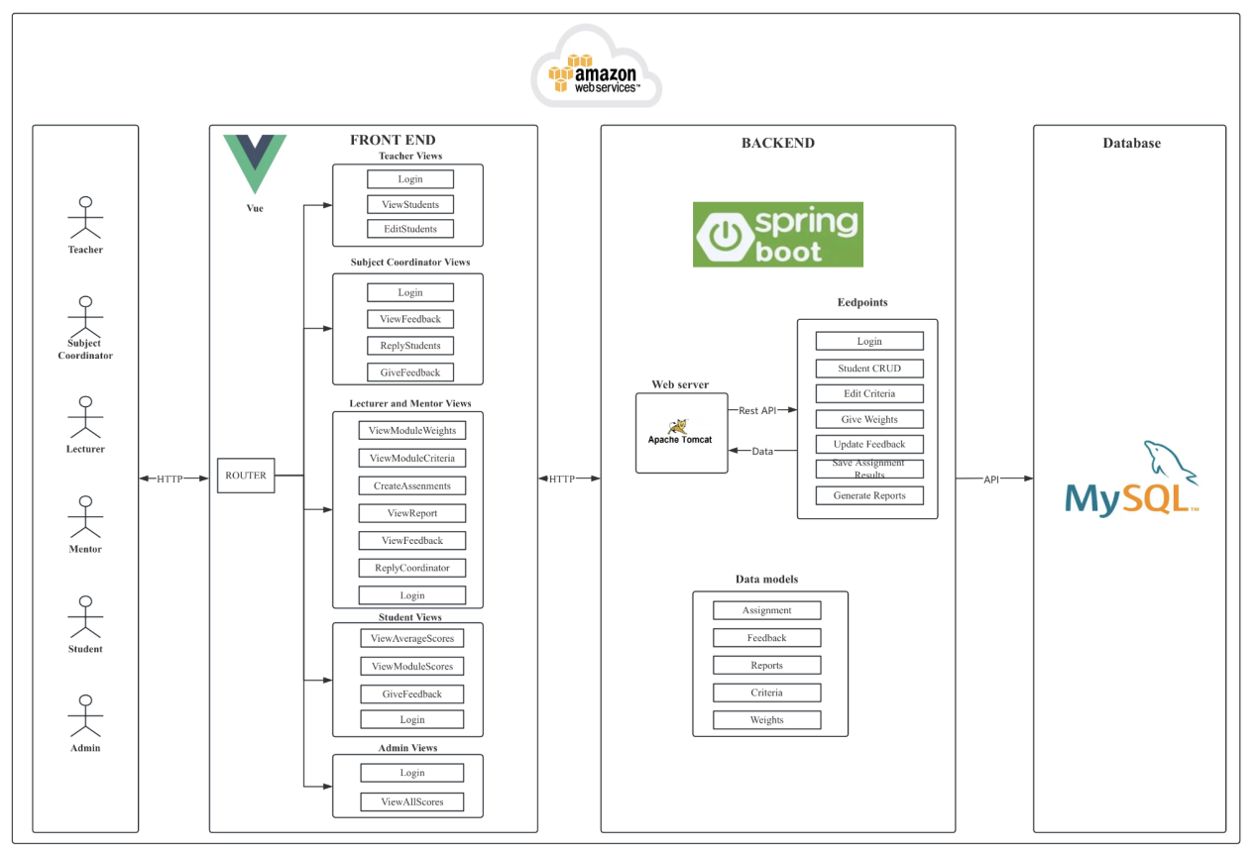

This software system architecture diagram illustrates an education management system based on a front-end and back-end separation, divided into three main parts: front-end, back-end, and database.

Front-End: The front-end uses the Vue.js framework and supports six roles: Teacher, Subject Coordinator, Lecturer, Mentor, Student, and Admin. Each role has access to different functional views based on their permissions, such as logging in, viewing and editing student information, managing feedback, and viewing scores.

Back-End: The back-end is built on the Spring Boot framework and is deployed using Apache Tomcat. It communicates with the front-end through REST APIs, providing functionalities such as user login, student management, feedback handling, and report generation. The back-end manages key data models including assignments, feedback, and reports.

Database: The database uses MySQL to store system data. The back-end interacts with the database through APIs, ensuring data persistence and consistency. The entire system is deployed on Amazon Web Services (AWS), with communication between the front-end and back-end via HTTP, and between the back-end and database via APIs.